LunchOrder Mastery Assignment
Reflection Log
Stefan S
CSE 3120 Object-Oriented Programming 1
(LunchOrder.java, Food.java)
How has your program changed from planning to coding to now? Explain.
You’ll notice, in my UML and in my program, that I didn’t include any methods to modify the class values. If this were a real program, I would have made the class access a spreadsheet or CSV file which contained each food and it’s respective values. This would make sense in a real program, because you DEFINITELY do not want to give a client the ability to modify prices and such anyways.
Currently, food types are managed as follows:
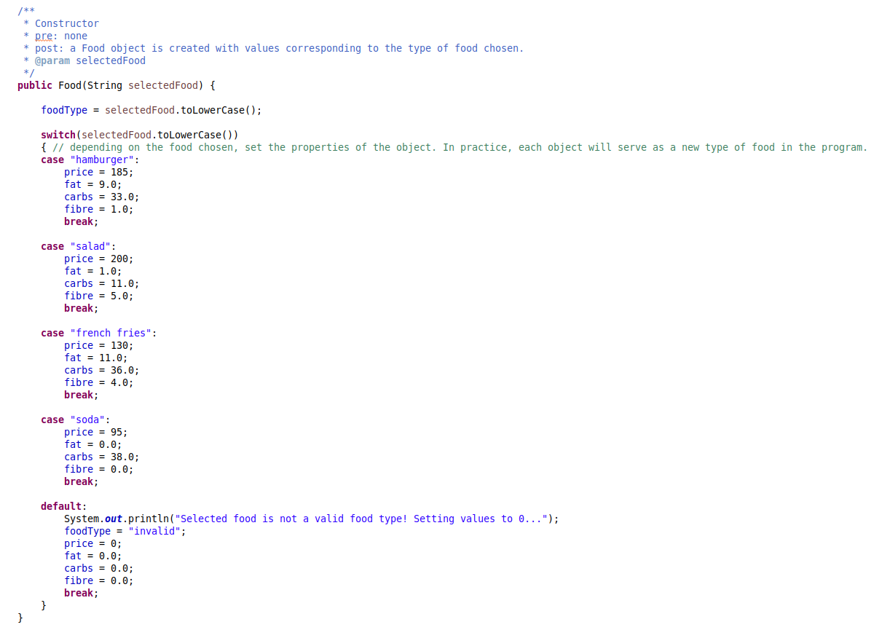

As a consequence of the way my class is designed, my client code is extremely repetitive. This sucks, but to fix it I would need to rewrite the whole class.

